Topic: Light PM Workshop
Date: 2/2/2019
By: Martijn Luyckx

To PMI Belgium

I would like to thank PMI Belgium for the recent project management workshop that you provided for us at the University of Hasselt. We are busy with a project to organise the next TEDxUHasselt event which takes place on March 23rd and it is our first time to run a project of this scale. We are all students and volunteers, so we appreciate any help we can get. Our PM workshop took place on Saturday 2nd of February and was attended by a number of team leaders and myself.

I would like to give our feedback on the top five things that we took from the workshop and that we will adopt for the rest of the project.

1) Light PM process
- The light project management process was very easy to understand and follow. It is also easy for us to explain this to other people involved in the project including our sponsor.
- Also the documentation for each step was easy to understand.
- If fact, the simple process gives a lot more confidence in how we are running the project.

2) Work Break Down Structure
- This is something we have not done before and we learned a lot from this exercise. We used post-it’s to breakdown our project into deliverables.
- This seems to be an excellent way for the project manager, team leaders and some users to recognise what needs to be done in the project and get some kind of early agreement of the size of the project.
- In the future, we would like to learn more about this technique and learn how to facilitate such a WBS workshop.
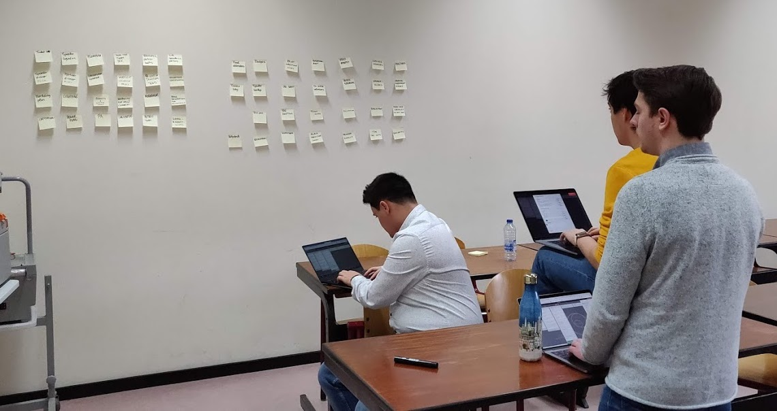

3) Requirements
- We think this was the most important part of the workshop for us as we had no real idea on how best to gather requirements.
- The idea of using a quality requirements checklist made this process easy to understand and we were able to document the requirements for about 15 deliverables during the workshop.
- I also see that this approach helps me as the project manager a lot with delegating especially, making it easy for people to understand what needs to be delivered and then confirm that the deliverable matches expectations.

4) Role Descriptions
- We have a lot of volunteers working on the project but we did not spend any time on defining the roles and responsibilities. This does not need to take too much time and we have decided to do this for each volunteer role.
- We wil also ask volunteer role to sign to show they understand what they need to do.

5) Communication and visualisation
- We can see the importance of keeping things as simple as possible and can also see that less information is more information meaning the simpler the progress information we provide, the more that will be understood.
- We really appreciate the Kanban board style of project board used for the project as this will help us do the following
  - Share project information with project team
  - Get feedback on the status of deliverables from the volunteers
  - Show current progress – using labels
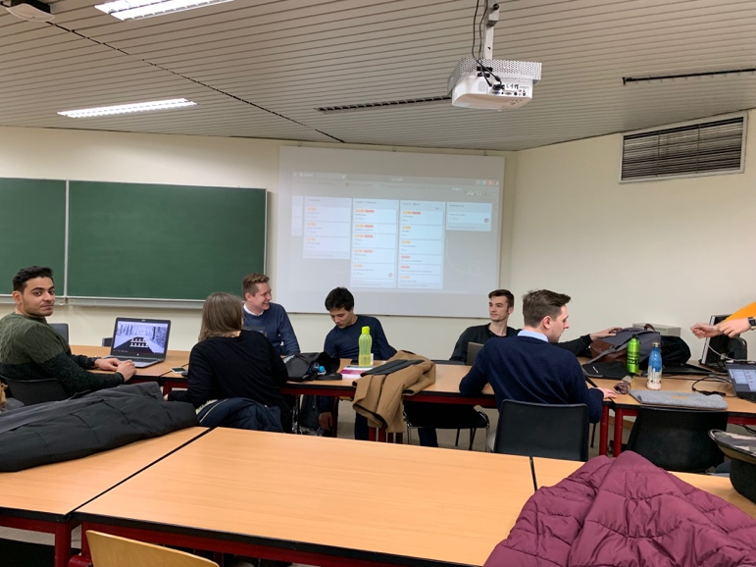
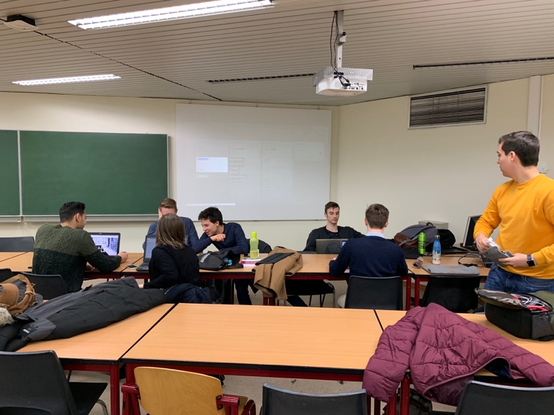
  - Quick access to document like the risk register, project summary, business case…

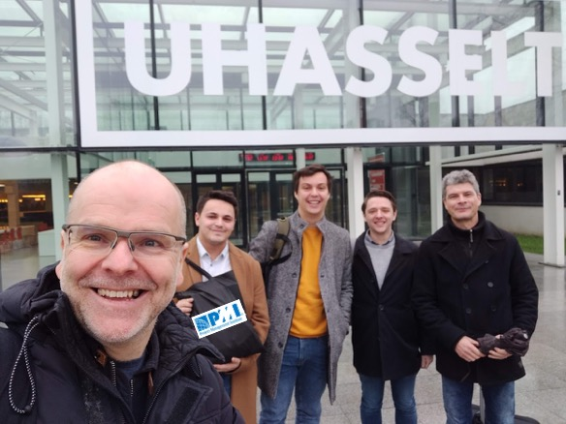

Thanks again PMI for your support in helping us to organise this TEDx event and we are interested in holding a bigger Light PM P3X workshop in the future for more students.

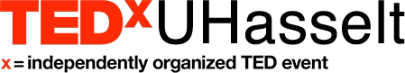
Martijn Luyckx
Project Manager

